**MINISTRY OF EDUCATION**

**AND TRAINING**

**FPT UNIVERSITY**

Capstone Project Document

Website of Law Firm Management System

Report #6 – Software User’s Manuals

|  |  |
| --- | --- |
| Website of Law Firm Management System | |
| Group Members | Lê Duy Hoàng – Team Leader – SE60744  Đặng Nguyễn Khiêm – Team Member – SE60595  Trần Anh Tuấn – Team Member – SE60631  Phạm Văn Duy – Team Member – SE60634 |
| Supervisor | Nguyễn Văn Sang |
| Capstone Project code | LFMS |

- Ha Noi, 09/2014 –

Contents

6.1.1. Introduction 3

6.1.2. Environment 3

6.1.3. Application Installation 3

6.2. User’s Guide 12

6.2.1. How to create a Calendar Event 12

6.2.2. How to view calendar event of other lawyer 13

6.2.3. How to create an Operation Event 14

6.2.4. How to upload photos to Documents Related 15

6.2.5. How to create a case 16

6.2.6. How to create a customer 17

6.2.7. How to create a Staff 18

6.2.8. How to create a service 19

6.2.9. How to create an office 20

6.2.10. How to view statistic 21

6.3. Project Result Report 23

6.3.1. Project judging 23

6.3.2. Project summary 23

6.3.3. Lesson learned 25

1. 1. Installation Guide

### Introduction

This document contains guide-lines step by step to use LFMS application, and set up its own database.

### Environment

Following are the software required to start the LFMS System:

- Operating System: Windows 7, Windows 8.

- Application server: LFMS application system requires an application server IIS version 7 running on Windows 7

- Browsers: Firefox 20 or higher.

- .NET 4.0 Framework

- Database: SQL Server 2008

- Tool: Microsoft visual studio 2010

### Application Installation

#### Database creation

Please follow these steps to create a new database for system:

* **Step 1**: Preparing database

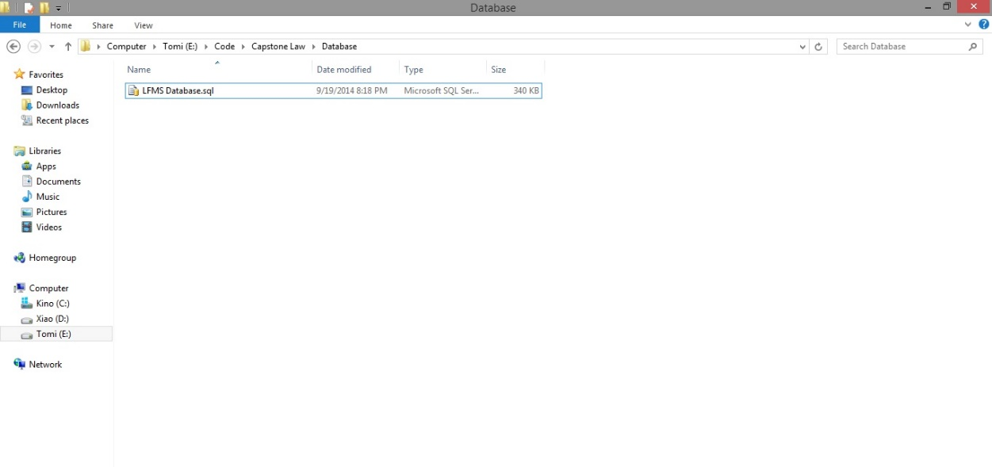

**Figure 6-1: Prepare Database**

They include a .sql file. The .sql file is database SQL scrip file.

* **Step 2**: Import database to SQL Server

Open Script file database using SQL Server

Copy user’s directory that has install SQL Server and replace this location in script file.

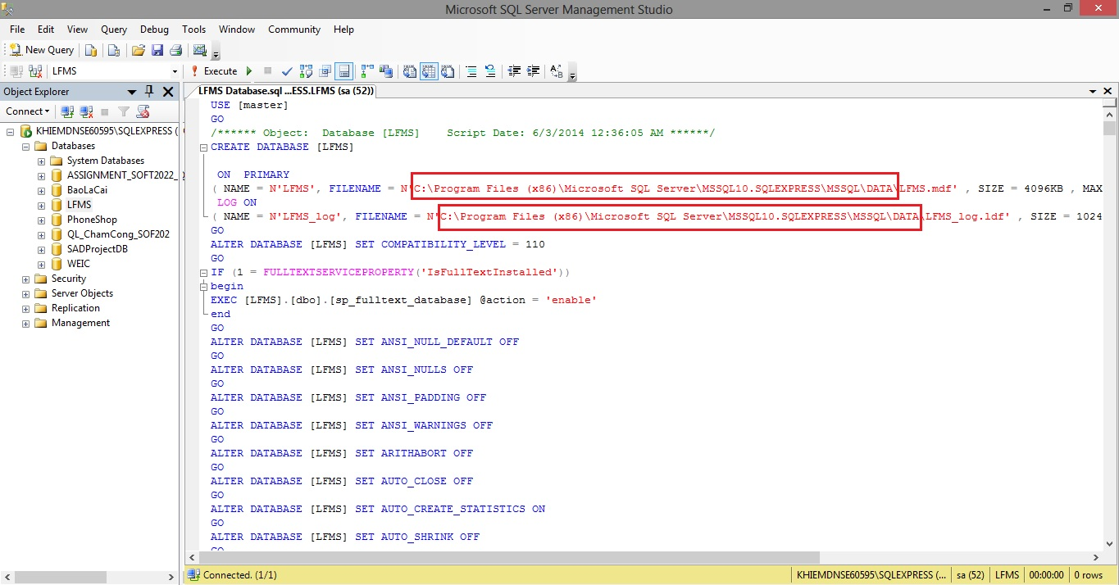

**Figure 6-2: Excute script database**

Excute script file to add new database into SQL Server

#### Setup Internet Information Services(IIS)

* **Step 1**: Go Start 🡪 Control panel 🡪 Click on Programs and Features 🡪 Click on Turn Windows features on or off.
* **Step 2**: Select this features in the picture below to install IIS Service.

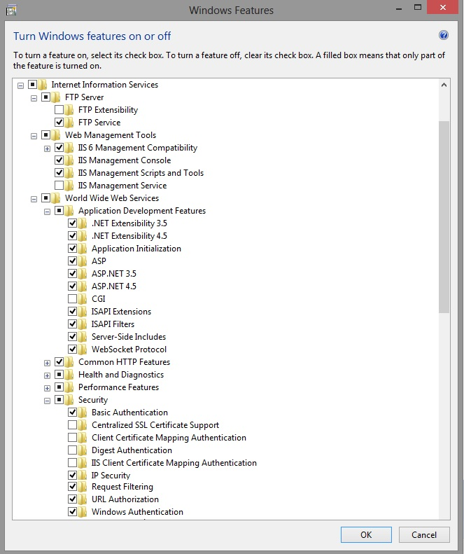

**Figure 6-3: Setup IIS-1**

* **Step 3**: Go Start 🡪 type Run 🡪 input inetmgr

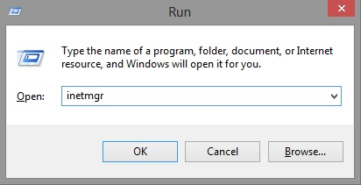

**Figure 6-4: Setup IIS-2**

**Step 4:** Go Application Pools 🡪 Right click to select Add Application Pool 🡪 Setup this like the picture below.

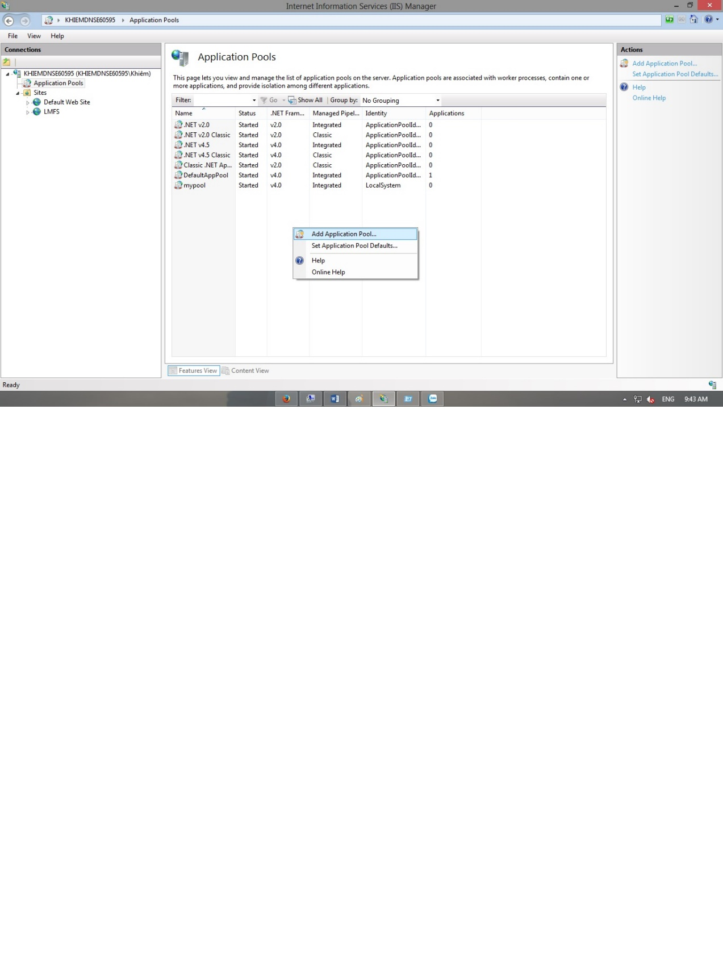

**Figure 6-5: Setup IIS-3**

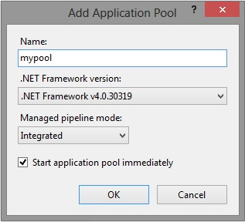

**Figure 6-6: Setup IIS-5**

* **Step 5:** Open Microsoft SQL Server Management Studio 🡪 Go Security 🡪 Right click to select New Login 🡪 Setup this like the picture below

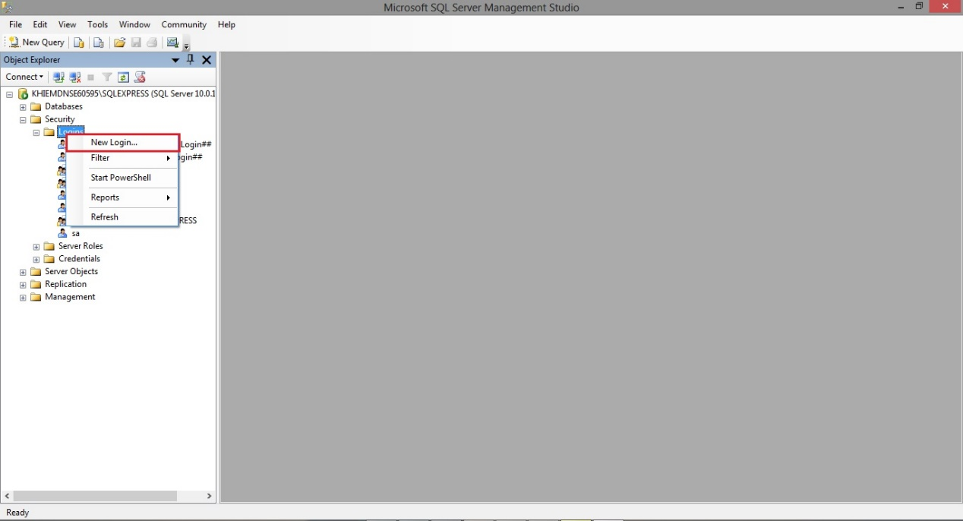

**Figure 6-7: Setup IIS-6**

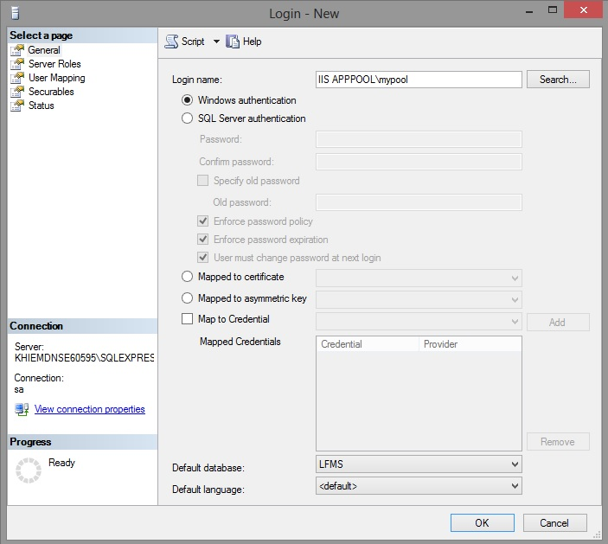

**Figure 6-8: Setup IIS-7**

**Step 6:** Go to login user has been created 🡪 Right click then select Properties 🡪 Click on User Mapping 🡪 Setup this like the picture below

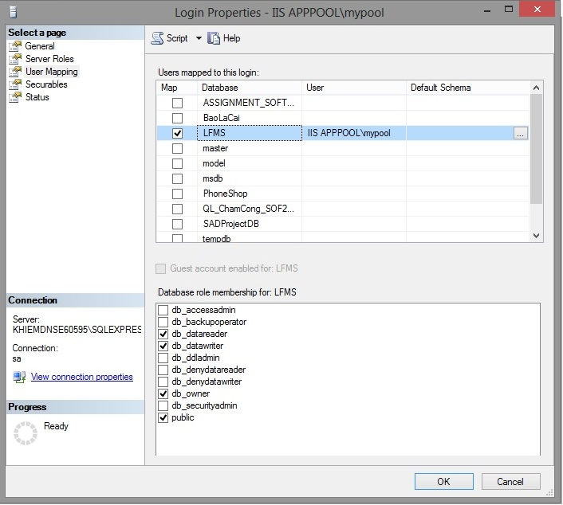

**Figure 6-9: Setup IIS-8**

#### Setup and Deloy website into IIS

* **Step 1:** Go Sites 🡪 Right click to select Add Website 🡪 Setup this like the picture below.

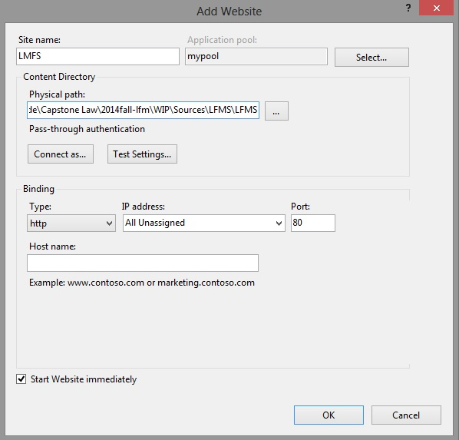

**Figure 6-10: Deploy website on IIS-1**

* **Step 2:** Goto website user has been created 🡪 Double click on Directory Browsing 🡪 Make this select Enable like the picture below.

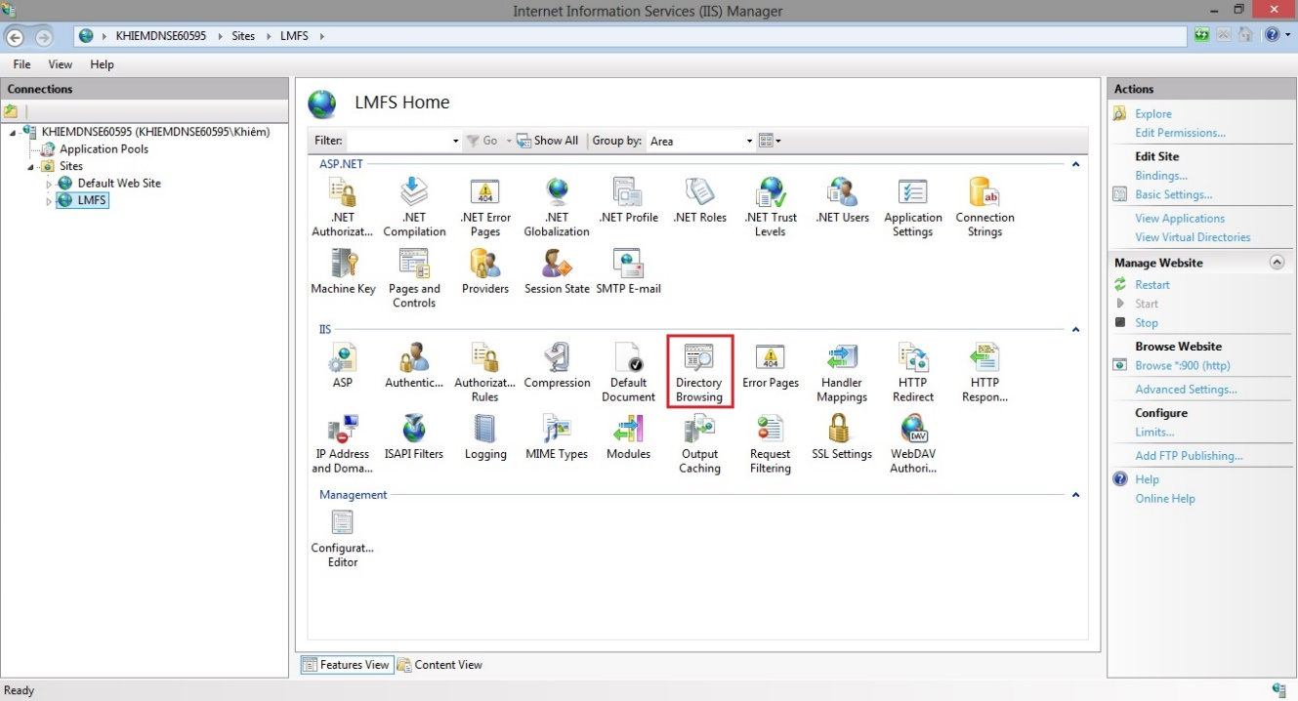

**Figure 6-11: Deploy website on IIS-2**

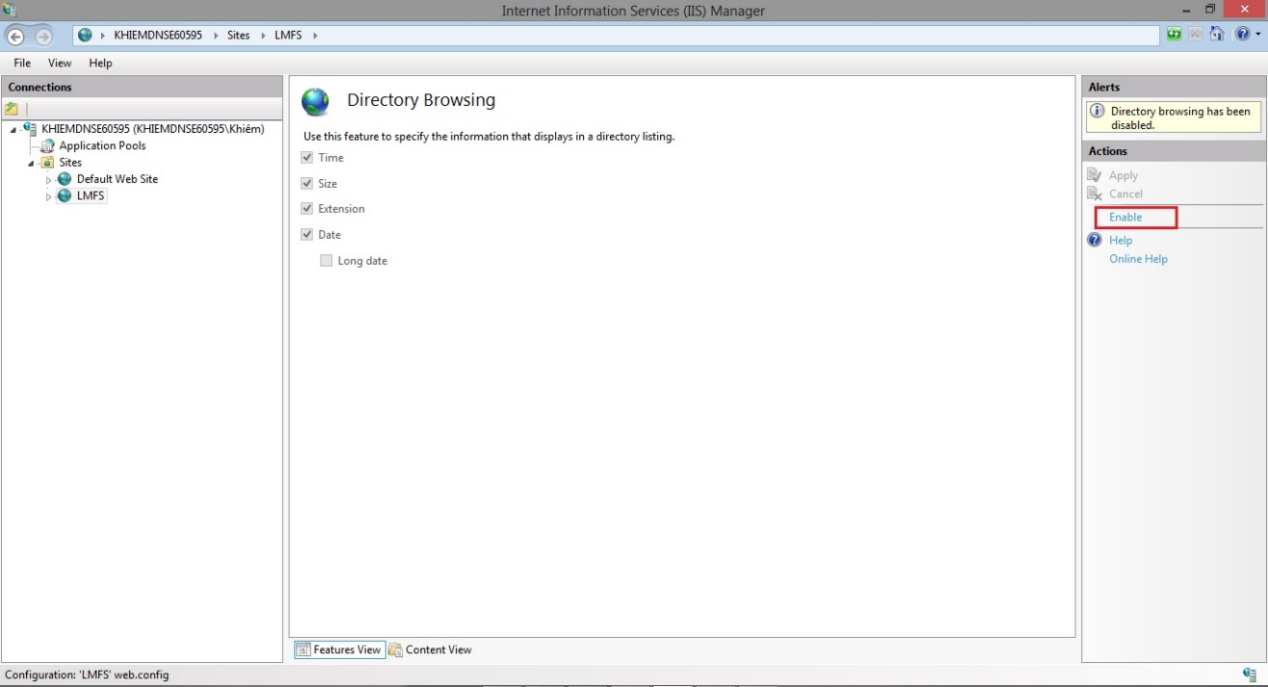

**Figure 6-12: Deploy website on IIS-3**

* **Step 3:** Goto website user has been created 🡪 Right click to select Manage website 🡪 Choose Browse like the picture below.

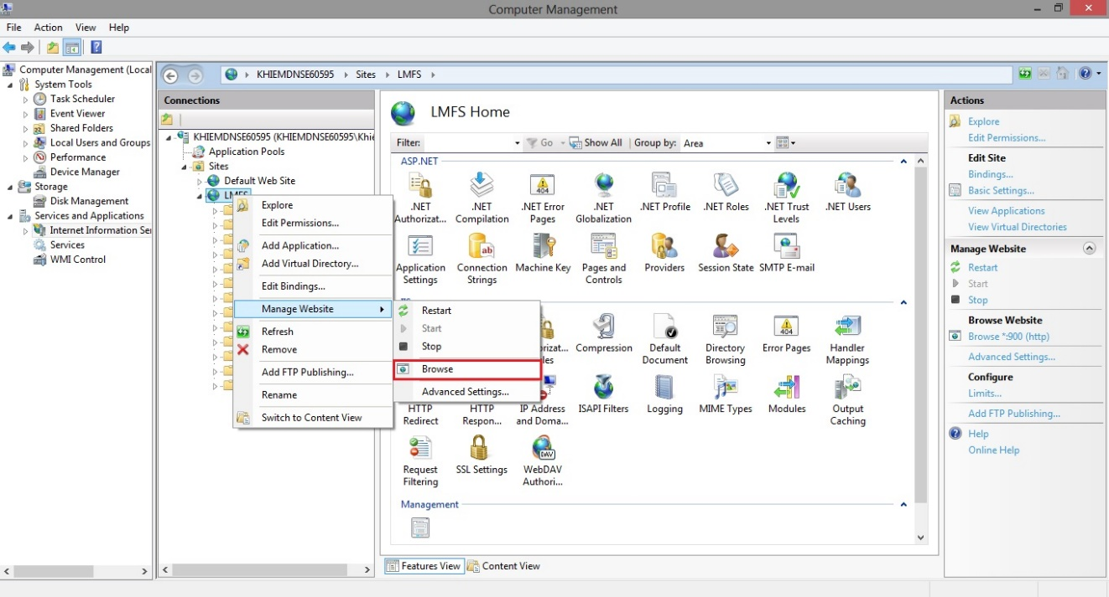

**Figure 6-13: Deploy website on IIS-4**

* 1. User’s Guide

### How to create a Calendar Event

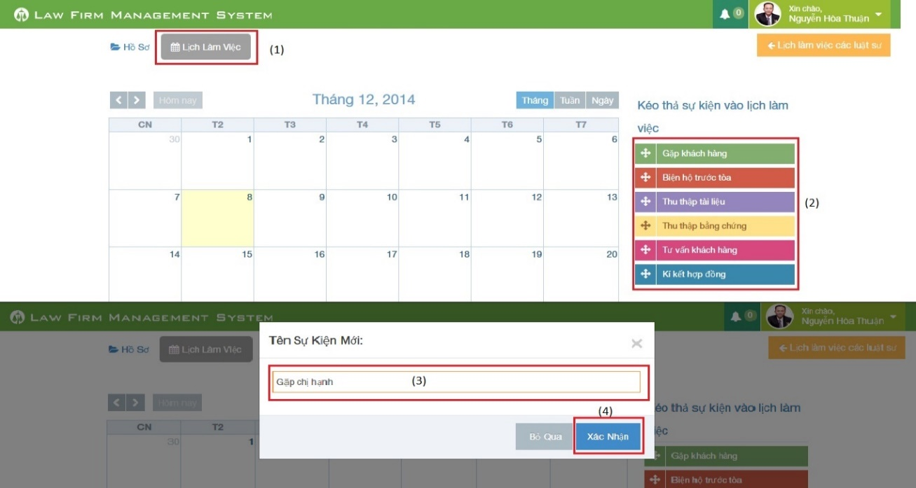

**Figure 6-14: How to create a Calendar Event**

|  |  |
| --- | --- |
| Step | Description |
| 1 | At Index page, click at “Lịch làm việc” tab |
| 2 | Drag any event and drop it into calendar.  (User can also click or click and drag anywhere in calendar to create a new event) |
| 3 | Input New calendar event name. |
| 4 | Press “Xác nhận” button to create new calendar event. |

### How to view calendar event of other lawyer

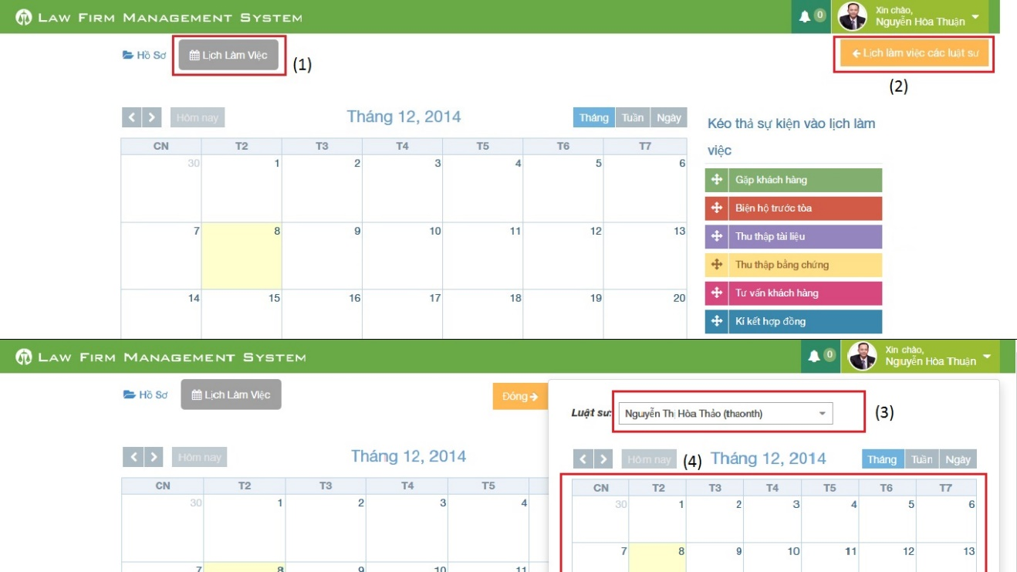

**Figure 6-15: How to view calendar event of other lawyer**

|  |  |
| --- | --- |
| Step | Description |
| 1 | At Index page, click at “Lịch làm việc” tab |
| 2 | At “Lịch làm việc” tab click at “Lịch làm việc các luật sư” |
| 3 | Choose a name of lawyer user want to view at combo-box |
| 4 | Calendar event will show below combo-box |

### How to create an Operation Event

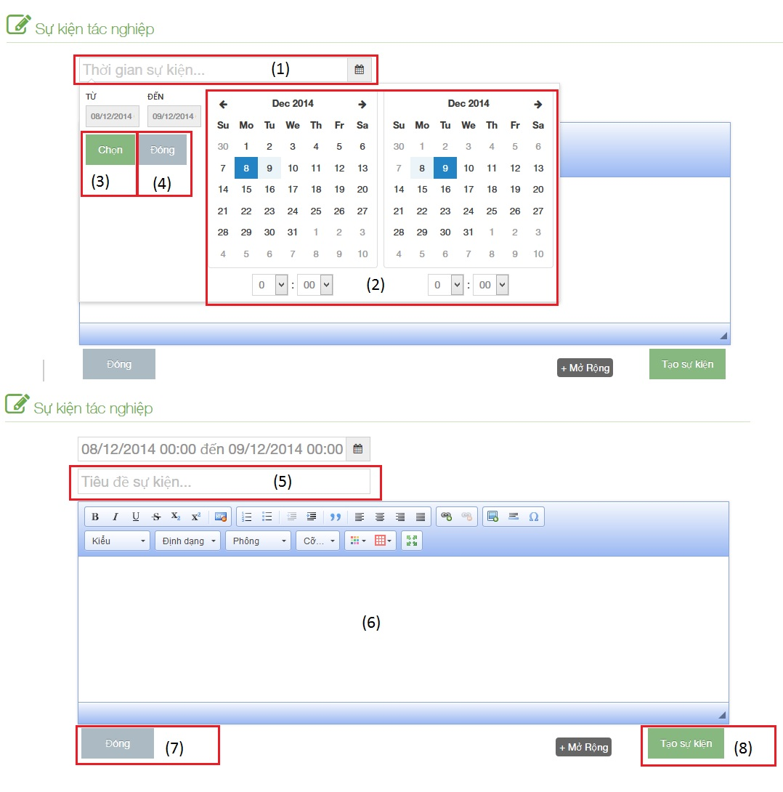

**Figure 6-16: How to create an Operation Event**

|  |  |
| --- | --- |
| Step | Description |
| 1 | Click to text box to add time start and finish of event |
| 2 | Choose date and time of event |
| 3 | Click [Chọn] button to input data on “Thời gian sự kiện” |
| 4 | Click [Đóng] button to cancel input |
| 5 | Input title of event |
| 6 | Input content of event include: text, image…. |
| 7 | Click [Đóng] button to close Popup and back to [List event] screen |
| 8 | Click [Tạo sự kiện] to insert new operation event |

### How to upload photos to Documents Related

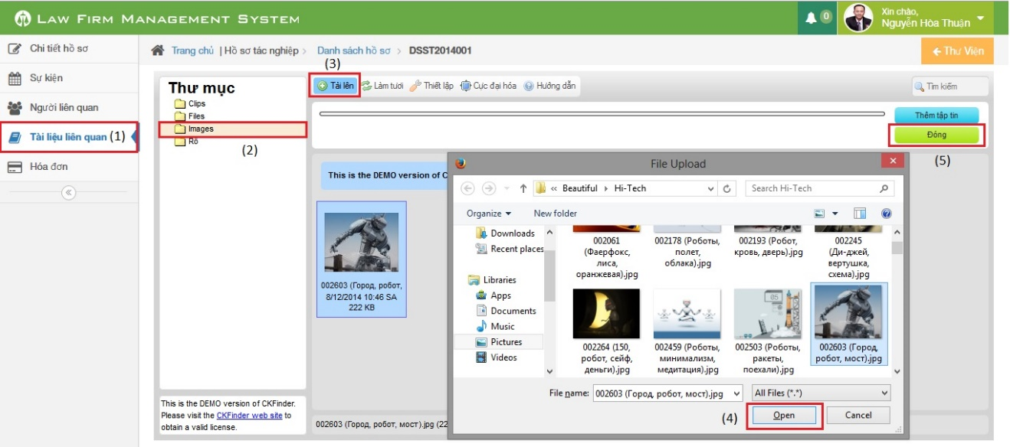

**Figure 6-17: How to upload photos to Documents Related**

|  |  |
| --- | --- |
| Step | Description |
| 1 | Go to case detail page and then click on “Tài liệu liên quan” link |
| 2 | Click on “Images” button (can upload only image file format) |
| 3 | Click on “Tải lên” button to show a popup |
| 4 | Choose one or many photos and then click “Open” button |
| 5 | Click on “Đóng” button to complete upload |

### How to create a case

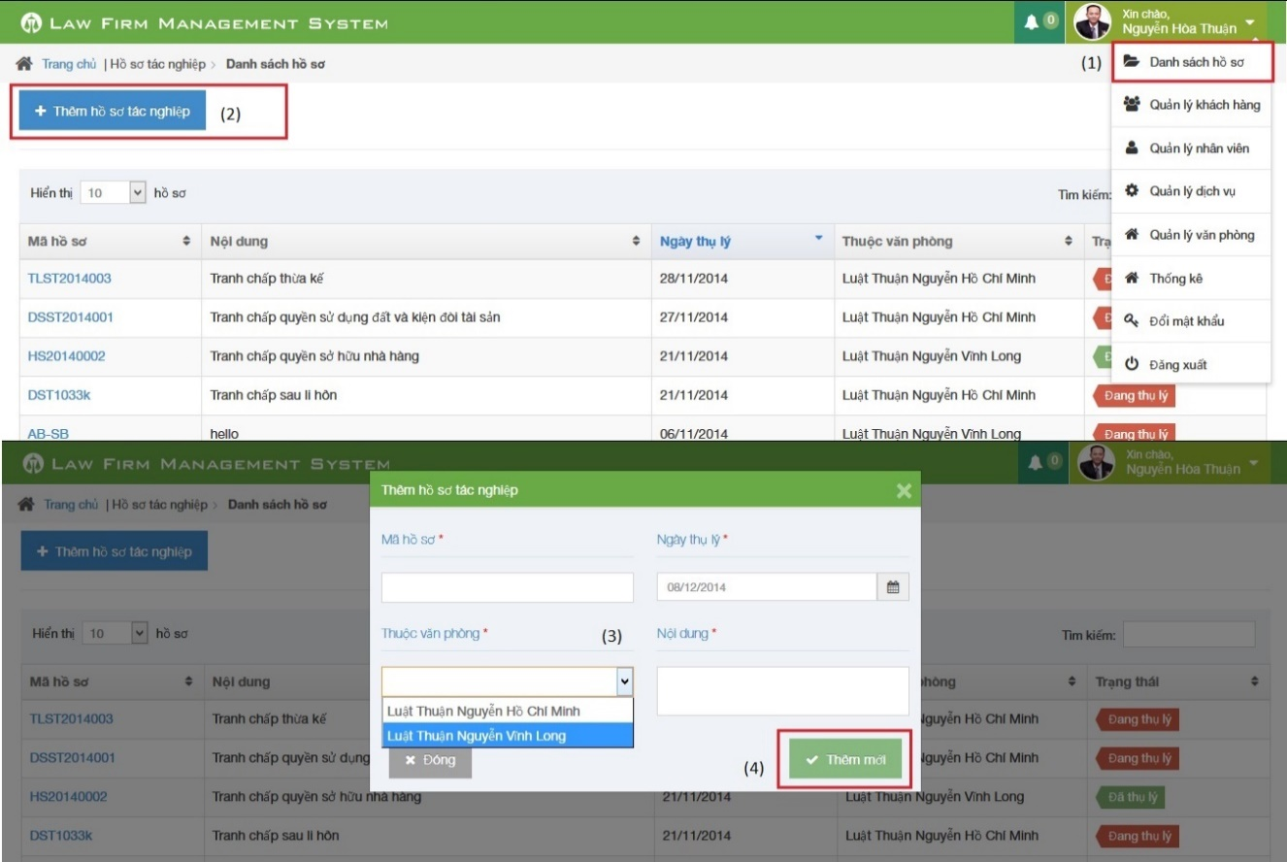

**Figure 6-18: How to create a Case**

|  |  |
| --- | --- |
| Step | Description |
| 1 | Click on list menu and then choose “Danh sách hồ sơ” to go to view list case page |
| 2 | Click on “Thêm hồ sơ tác nghiệp” to show a popup |
| 3 | Fill information of case:  - Mã hồ sơ, Ngày thụ lý, Thuộc văn phòng, Nội dung is required |
| 4 | Click [Thêm mới] button to insert new case |

### How to create a customer

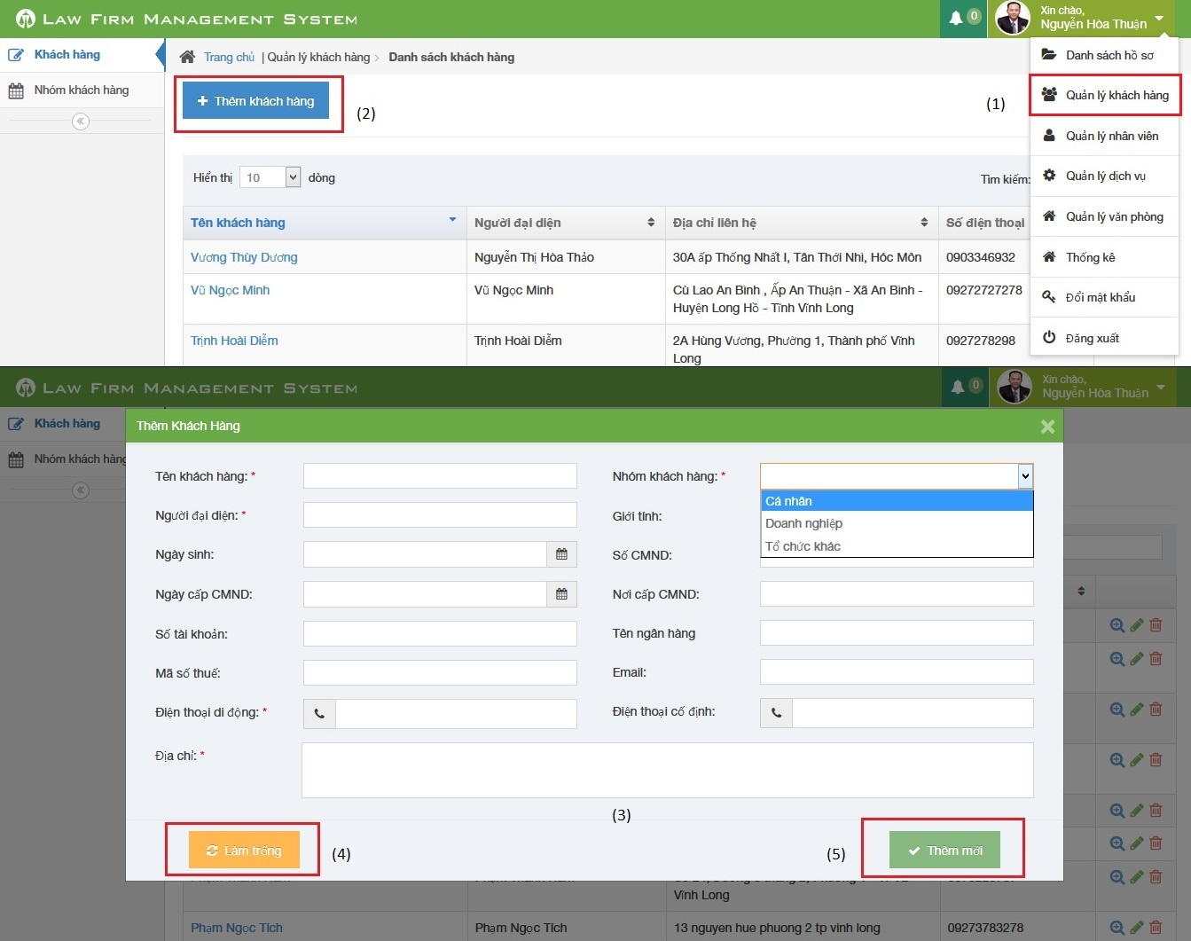

**Figure 6-19: How to create a Customer**

|  |  |
| --- | --- |
| Step | Description |
| 1 | Click on list menu and then choose “Quản lý khách hàng” to go to view list customer page |
| 2 | Click on “Thêm khách hàng” to show a popup |
| 3 | Fill information of case:  - Tên khách hàng, Người đại diện, Nhóm khách hàng, Điện thoại di động, Địa chỉ is required  - Điện thoại di động, Điện thoại cố định, số CMND, Mã số thuế, Số tài khoản must be number  - Email to compliance with format |
| 4 | Click [Làm trống] button to clear all fill to blank. |
| 5 | Click [Thêm mới] button to insert new customer |

### How to create a Staff

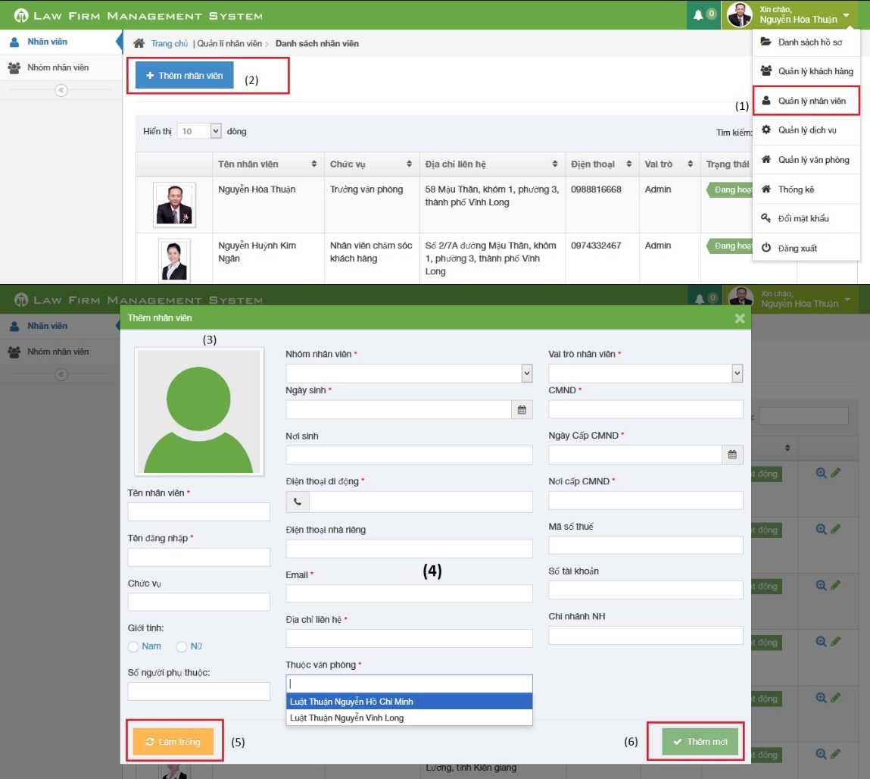

**Figure 6-20: How to create a Staff**

|  |  |
| --- | --- |
| Step | Description |
| 1 | Click on list menu and then choose “Quản lý nhân viên” to go to view list staff page |
| 2 | Click on “Thêm nhân viên” to show a popup |
| 3 | Click to input avatar of staff |
| 4 | Fill information of staff:  - Tên nhân viên, Tên đăng nhập, Nhóm nhân viên, Ngày sinh, Điện thoại di động, Email, Địa chỉ liên hệ, Thuộc văn phòng, Vai trò nhân viên, CMND, Ngày cấp CMND, Nơi cấp CMND is required  - Điện thoại di động, Điện thoại nhà riêng, CMND, Mã số thuế, Số tài khoản must be number  - Email to compliance with format |
| 5 | Click [Làm trống] button to clear all fill to blank. |
| 6 | Click [Thêm mới] button to insert new staff |

### How to create a service

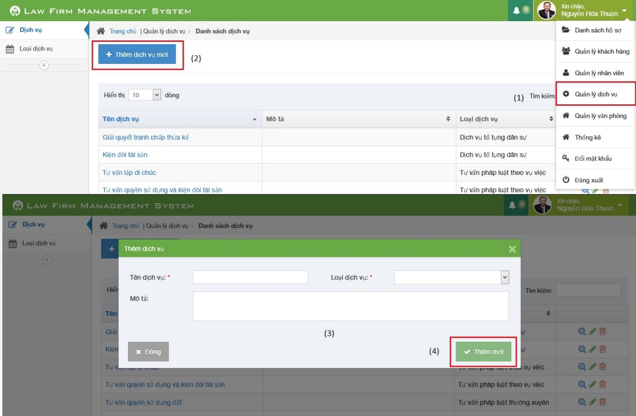

**Figure 6-21: How to create a service**

|  |  |
| --- | --- |
| Step | Description |
| 1 | Click on list menu and then choose “Quản lý dịch vụ” to go to view list service page |
| 2 | Click on “Thêm dịch vụ mới” to show a popup |
| 3 | Fill information of case:  - Tên dịch vụ, Loại dịch vụ is required |
| 4 | Click [Thêm mới] button to insert new service |

### How to create an office

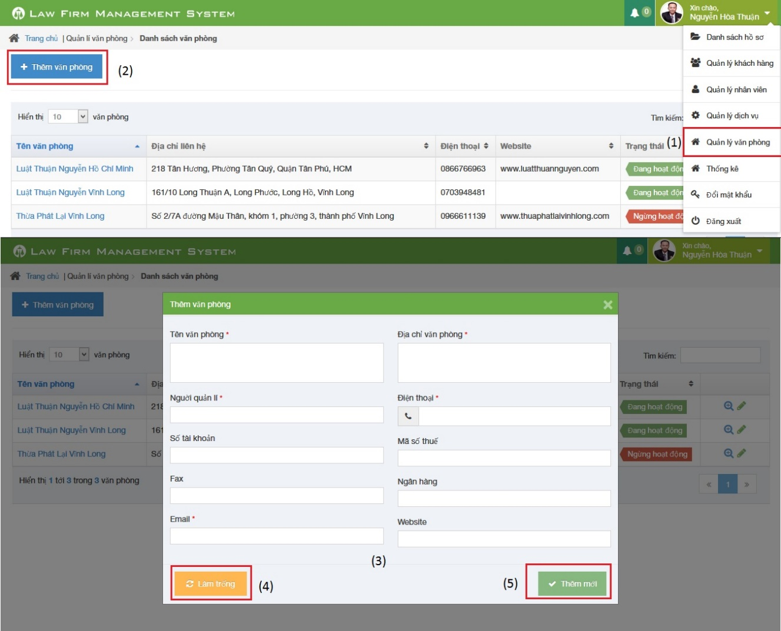

**Figure 6-22: How to create a Staff**

|  |  |
| --- | --- |
| Step | Description |
| 1 | Click on list menu and then choose “Quản lý văn phòng” to go to view list office page |
| 2 | Click on “Thêm văn phòng” to show a popup |
| 3 | Fill information of case:  - Tên văn phòng, Địa chỉ văn phòng, Người quản lí, Điện thoại, Email is required  - Điện thoại, Mã số thuế, Số tài khoản must be number  - Email to compliance with format |
| 4 | Click [Làm trống] button to clear all fill to blank. |
| 5 | Click [Thêm mới] button to insert new service |

### How to view statistic

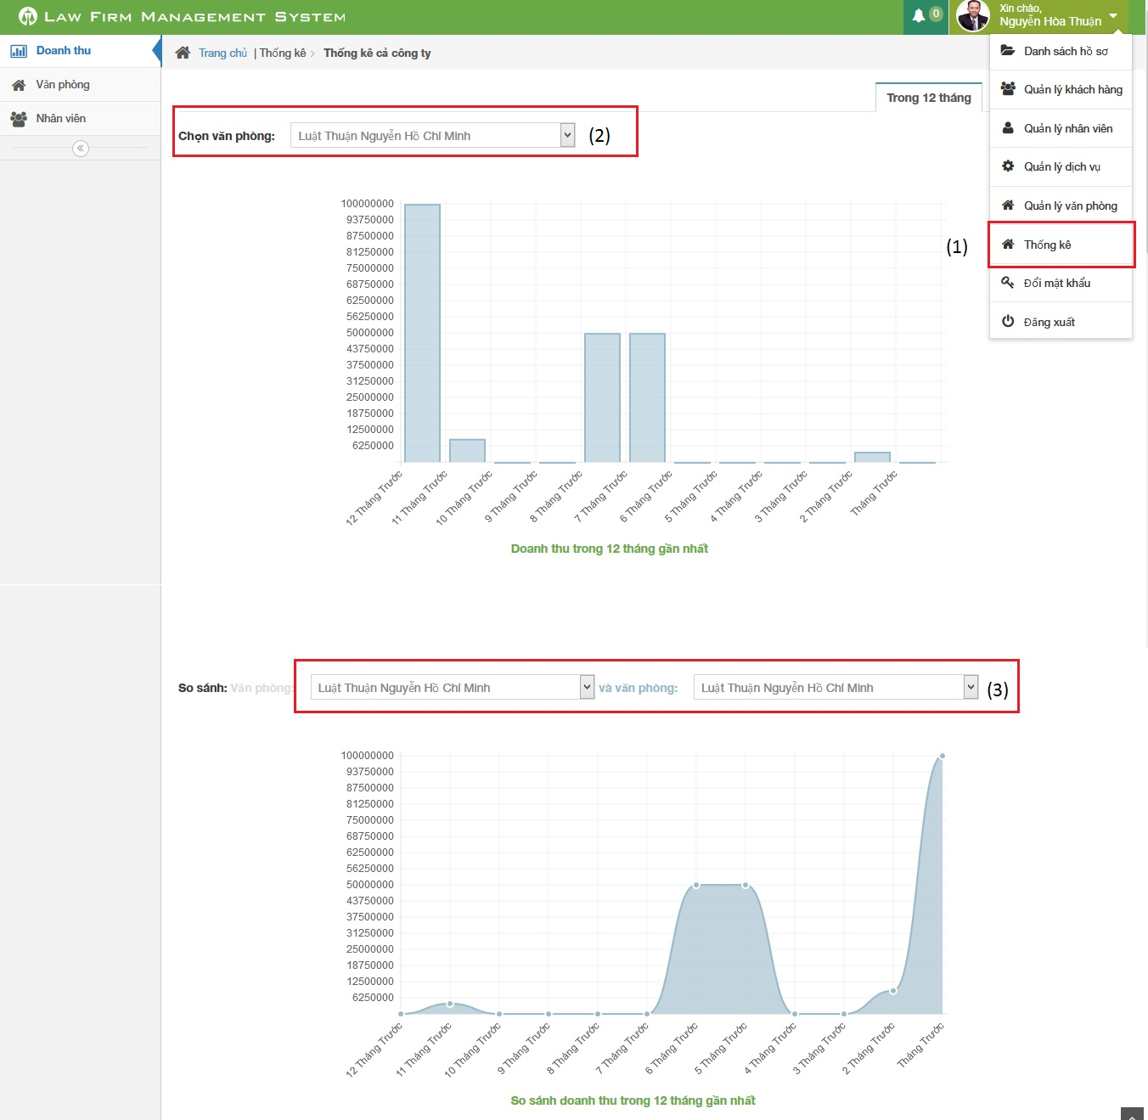

**Figure 6-23: How to view statistic**

|  |  |
| --- | --- |
| Step | Description |
| 1 | Click on list menu and then choose “Thống kê” to go to view list statistic page |
| 2 | Choose office user want to show statistic |
| 3 | Choose two office user want to compare in statistic |

* 1. Project Result Report

### Project judging

#### Advantages of LFMS

The idea of the LFMS is to develop a new website for “Thuan Nguyen Lawyer Office. It has main features of existing website such as easy to manage than traditional methods, online data storage and centralized etc… Besisdes, it has some extra functions: schedule notify each time event occur and statistic in every year

* Lawyers can work more effective, easier and simpler way without remember schedule and operation event.
* Law firm can manage all information like case, customer, staff service and office easier.
* Accounting easier with auto statistical in every year.

#### Current limitations of LFMS

However, some limitations still exist

* Still not using search in “Thư viện pháp luật”
* Only support Firefox

#### Expectation in future

* Develop function search in “Thư viện pháp luật”
* Support more in other browser

### Project summary

|  |  |  |  |  |  |
| --- | --- | --- | --- | --- | --- |
| **Project Title** | | | Website of law firm management system | | |
| **Project Supervisor** | | | Nguyễn Văn Sang | | |
| Committers (5) | | | | | |
| 1 | Project Manager | | Lê Duy Hoàng | | [Hoangldse60744@fpt.edu.vn](mailto:Hoangldse60744@fpt.edu.vn) |
| 2 | Project Technical Leader | | Lê Duy Hoàng | | [Hoangldse60744@fpt.edu.vn](mailto:Hoangldse60744@fpt.edu.vn) |
| 3 | Developer | | Đặng Nguyễn Khiêm | | [Khiemdnse60595@fpt.edu.vn](mailto:Khiemdnse60595@fpt.edu.vn) |
| 4 | Developer | | Phạm Văn Duy | | [Duypvse60634@fpt.edu.vn](mailto:Duypvse60634@fpt.edu.vn) |
| 5 | Tester | | Trần Anh Tuấn | | [[Tuantase60631@fpt.edu.vn](mailto:Tuantase60631@fpt.edu.vn)](mailto:Minhtc01748@fpt.edu.vn) |
| Main objective | | Develop a website that helps users can manage all information like case, customer, staff, service and office easier. | | | |
| Purpose | | Lawyers can work more effective, easier and simpler | | | |
| **Items** | | **Plan** | | **Actual** | |
| Releases Date | | 25/12/2013 | | 27/12/2013 | |
| Releases version | | 1.0 | | 1.0 | |
| Days | | 78 | | 80 | |
| Test cases | |  | | 223 test case | |
| Defects | |  | | 8 | |
| Document pages | |  | | > 200 (include appendix) | |
| Lines of code | |  | | Approximately 50.000 | |

### Lesson learned

* Before this capstone project, we do not know much about ASP. Net MVC4, Ajax and C #language. After more than 3 months, we have more experience and deeply understand how to create a MVC4 website, how to face with problems and bugs in developing a MVC4 website.
* We also improved lots of skills
  + - * Firstly, about technical, we know how to develop application with C# language, how to use SVN to store source code and how to work efficiently with Microsoft Office.

Secondly, about soft skills, while doing this project, we can gain skills in how to work with team efficiently, how to avoid conflict in team members. After lots of team meeting, we know how to brainstorm with all team to generate creative idea or solution to a problem. In addition, two important skills are researching and self-studying, we have to research and self-study a lot to do our work in project, to solve a problem.

* + - * Finally, one of the most important skill we have learnt through this project is project management. We know how to manage a project from the beginning to the end, how to create project plan, how to collect requirements, how to create SRS, how to design an application, how to create test cases etc. It is very important for our job in the future.
* Through this capstone project, we have more expreriences in risk and issues management
  + - * About technique :
        + Some members do not have high level in work with ASP. Net MVC 4, Ajax, Jquery before start this project so we assign some members to take responsibility for researching and training the others.
        + Members do not understand about some general techniques such as searching in internet or asking for supporting from community. We have to support to guide each other to work efficiently.
      * About human resources:
        + Some members are lazy for a while; they cannot finish their work before deadline or cannot do their tasks so we define detail schedules, and often reminding each other.
        + We held lots of team meeting for team members to meet each other, to brainstorming to think about solution of a problem and to support other members.
        + Team members must report what they do twice a week and project manager has to define schedule according to members’ capability.
      * About the missing deadline, there are some reasons
        + The coding language is new with us, so we need more time to be acquainted with it.
        + Sometimes source code has problems and members cannot check in, check out to submit their works